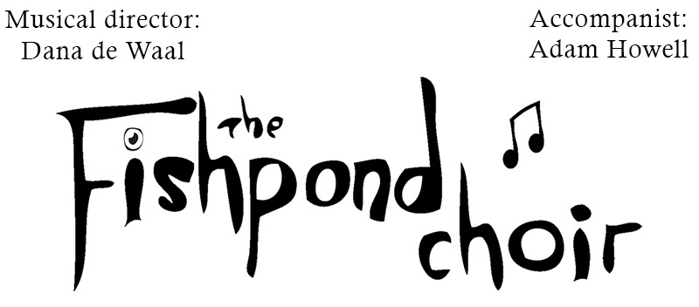
Please reply to:
Louise Amandini
Secretary Fishpond Choir
secretary@fishpondchoir.com
07876543171

Thank you for your request for the Fishpond Choir to perform for you. Please fill in this questionnaire to the best of your knowledge and return it to the Secretary of the Fishpond Choir at the above address. Your request will be discussed at the next committee meeting (held approximately every 6 weeks) after which you will be contacted. Our normal fee for a performance is £300.00.

The choir performs up to 2 concerts a year with all proceeds to the charity. The format is usually two 45 minutes halves with a 20 minute interval. This interval is a good chance to raise further funds for your chosen charity (if appropriate) through a raffle, refreshments etc.

1 | Your Name
2 | Name of the organisation you represent
3 | Address and telephone number
4 | Email
5 | Name and address of proposed venue
6 | Preferred dates and times
7 | How many singers (with room to hold music) can be accommodated?
8 | Do you have tiered staging available? (we can still accept bookings without this)
9 | Do you have a tuned piano available? (we can still accept bookings without this)
10 | Are you a charity requesting a concert without a fee?
11 | If you wanted a charity concert & we can’t help this year do you still wish to make a (paid) booking?
12 | Does the venue have adequate lighting for the choir to read music by?
13 | Will you produce posters and other publicity and sell your own tickets?
14 | Does the venue comply with current health and safety standards?
15 | Does the venue hold a current licence to allow public performances to take to place?
16 | Does the venue have public liability insurance?
17 | Any other comments?

It would be very much appreciated if refreshments (e.g. tea or juice) were provided for the choir during the interval. The choir is usually between 50 and 60 in number for concerts.

If we can agree dates and terms we may request a visit to the venue to carry out a site check.

For further information please look on our website www.fishpondchoir.com

